**Analysing the Performance & Efficiency of the Radisson Hotels using Data Visualization Techniques**

1. **Introduction**
   1. Overview

The hotel industry is a broad category of businesses that provide lodging services for travellers and tourists. This can include a wide range of establishments, from luxury resorts to budget-friendly motels, as well as extended stay hotels, boutique hotels, and more. Hotels can be found in nearly every corner of the world, and are often a major component of the tourism and travel industry in a given area.

Radisson owns multiple five-star hotels across India. They have been in the hospitality industry for the past 100 years. Due to strategic moves from other competitors and ineffective decision-making in management, Radisson is losing its market share and revenue in the luxury/business hotels category. As a strategic move, the managing director of Radisson wanted to incorporate Business and Data Intelligence in order to regain their market share and revenue. Our task is to create an analytics dashboard & story to provide them insights to make better business decisions.

1.2 Purpose

Radisson is losing its market share and revenue in the luxury/business hotels category. As a strategic move, the managing director of Radisson wanted to incorporate Business and Data Intelligence in order to regain their market share and revenue. Our task is to create an analytics dashboard & story to provide them insights to make better business decisions.

1. **Problem definition & Design thinking**

2.1 Empathy map

The hotel industry is a broad category of businesses that provide lodging services for travellers and tourists. This can include a wide range of establishments, from luxury resorts to budget-friendly motels, as well as extended stay hotels, boutique hotels, and more. Hotels can be found in nearly every corner of the world, and are often a major component of the tourism and travel industry in a given area.

Radisson owns multiple five-star hotels across India. They have been in the hospitality industry for the past 100 years. Due to strategic moves from other competitors and ineffective decision-making in management, Radisson is losing its market share and revenue in the luxury/business hotels category. As a strategic move, the managing director of Radisson wanted to incorporate Business and Data Intelligence in order to regain their market share and revenue. Our task is to create an analytics dashboard & story to provide them insights to make better business decisions.

**3. Result**

Final finding output of the project along with screenshots

**3.1 Revenue Split By City**

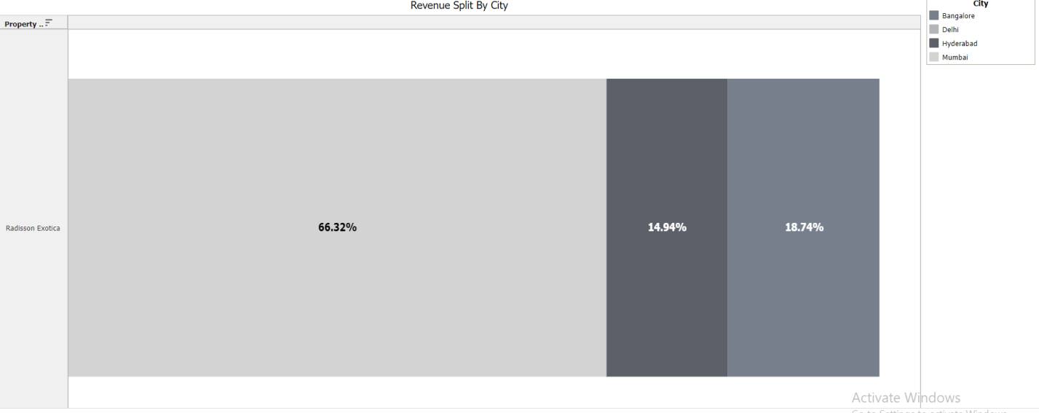

**3.2 Occupancy Split By City**

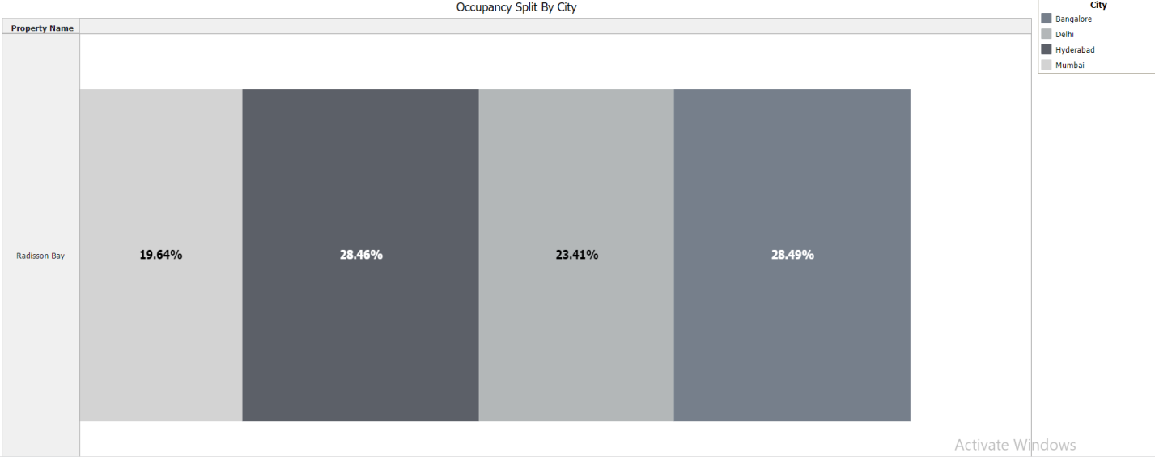

**3.3 Occupancy By Day Type**

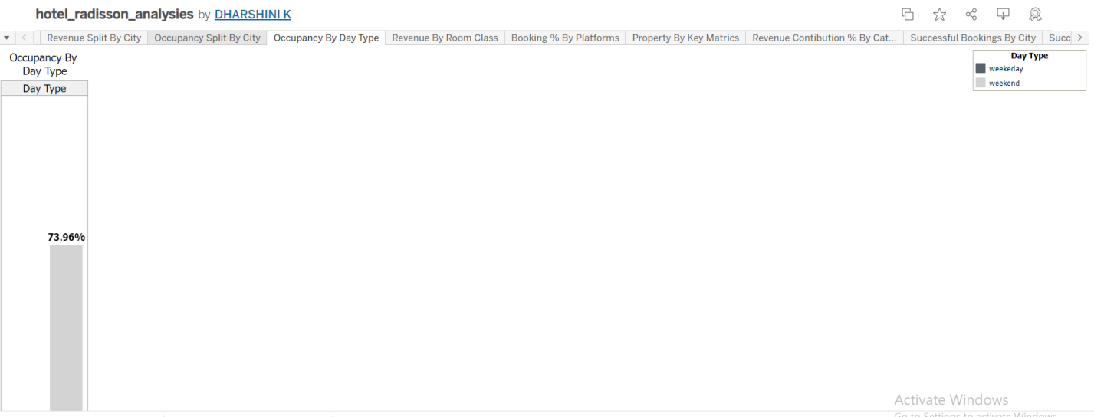

**3.4. Revenue By Room Class**

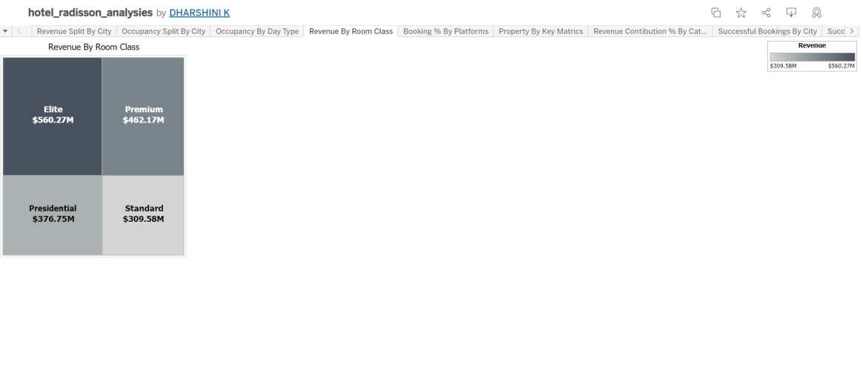

**3.5. Booking % By Platform**

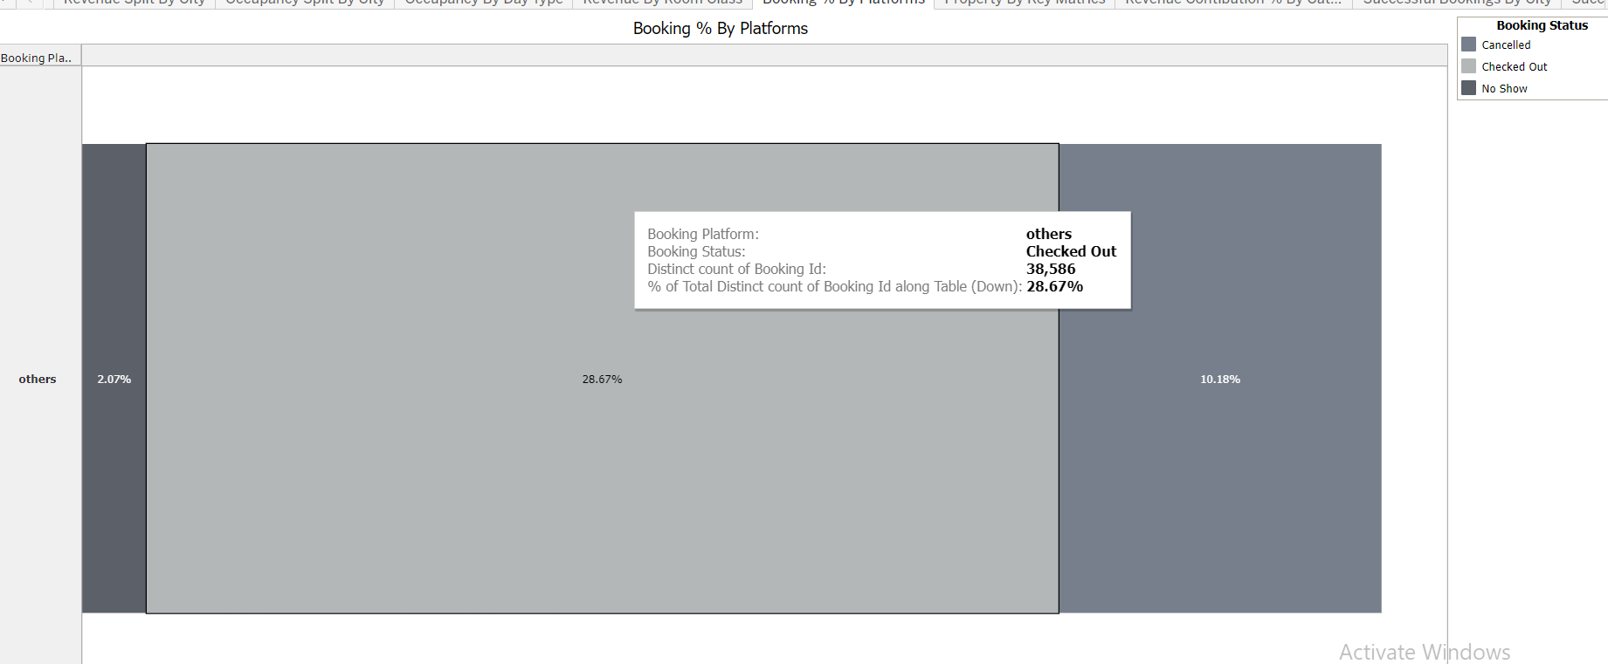

**3.6. Property by key metrics**

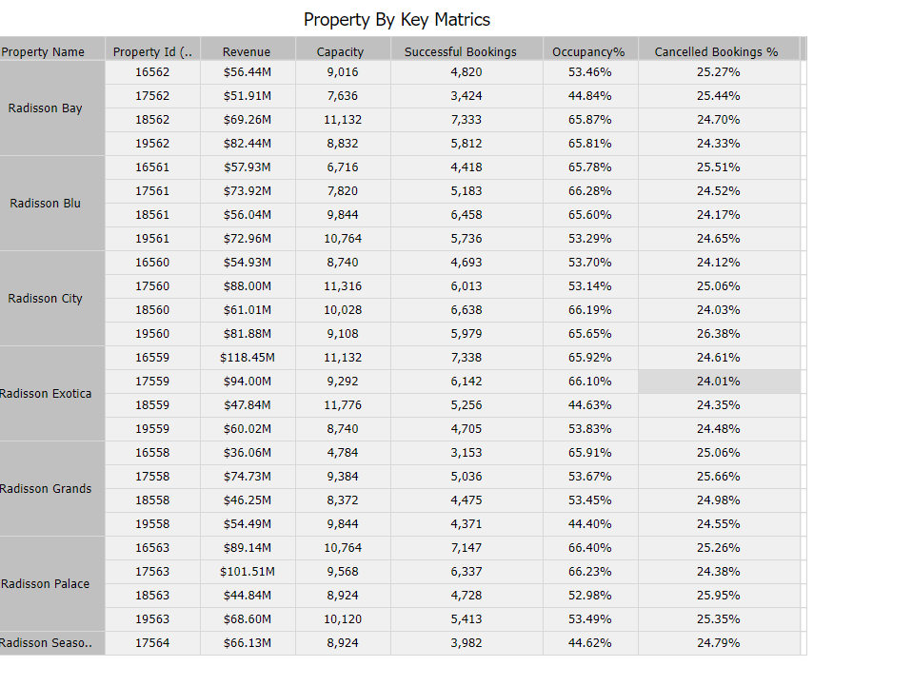

**3.7 Revenue Contribution % By Category**

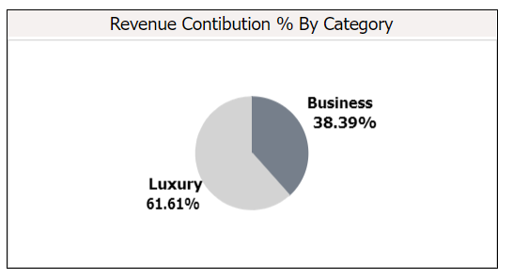

**3.8 Successful Bookings By City**

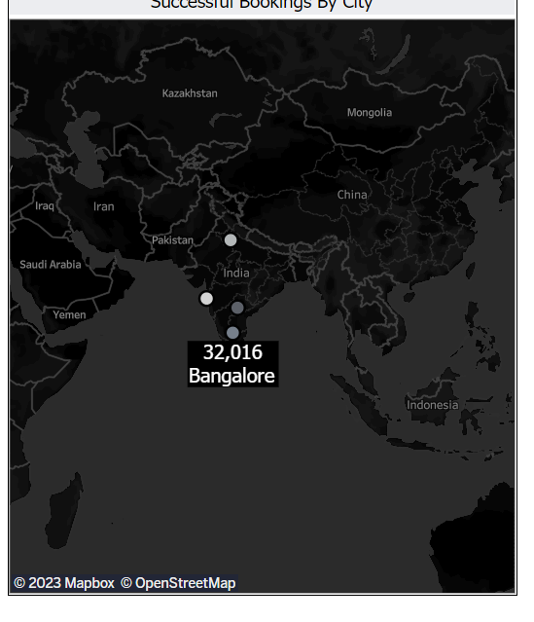

**3.9 Successful Booking By Date Wise**

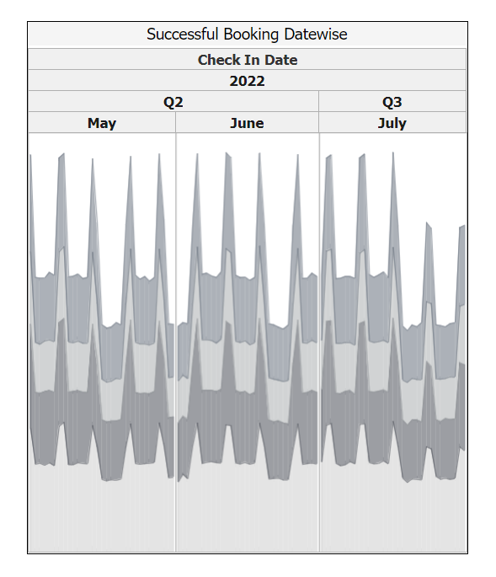

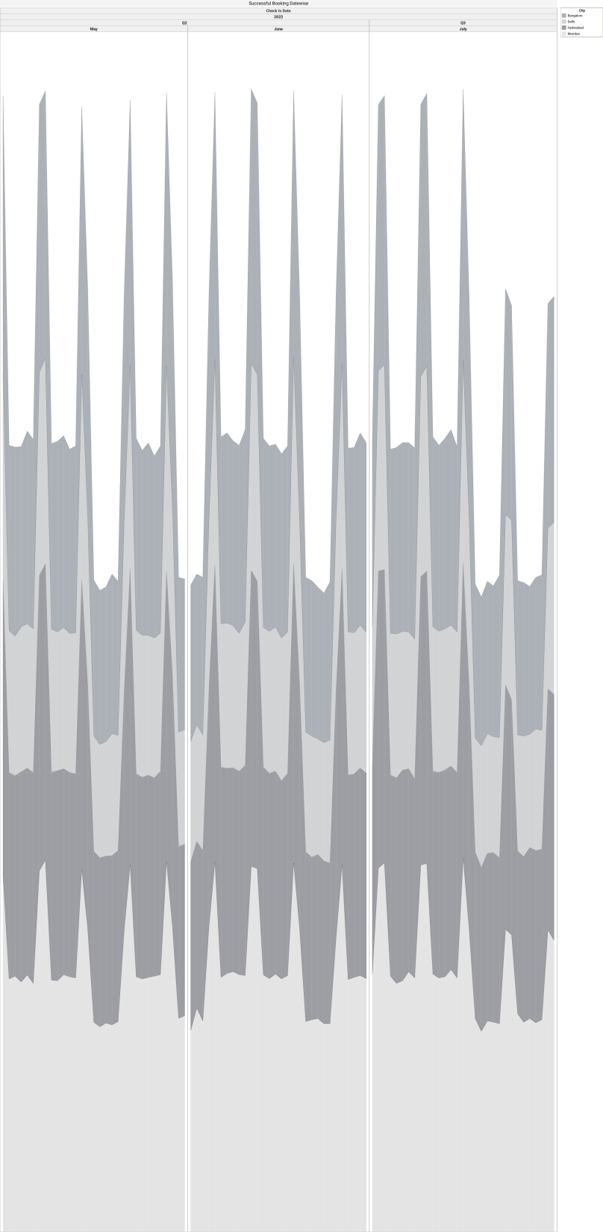

**3.10 Total Revenue For The Hotels**

**$1708.77 M**

**3.11. Total Successful Bookings**

**$ 134.59 M**

**3.12 Occupancy In %**

**57.87 %**

**4. Advantages & Disadvantages**

**Advantages of Data Visualization :**

**Better agreement –**

In business numerous a period it happens that we need to look at the exhibitions of two components or two situations. A conventional methodology is to experience the massive information of both the circumstances and afterward examine it. This clearly will kill a great deal of time.

**A superior method –**

It can tackle the difficulty of placing the information of both perspectives into the pictorial structure. This will unquestionably give a superior comprehension of the circumstances. For instance, Google patterns assist us with understanding information identified with top ventures or inquiries in pictorial or graphical structures.

**Simple sharing of data –**

With the representation of the information, organizations present another arrangement of the correspondence. Rather than sharing the cumbersome information, sharing the visual data will draw in and pass on across the data which is more absorbable.

**Precise investigation –**

With the assistance of information perception, it gets more obvious the patterns and hence draws a superior surmising of the information. Accordingly, giving associations an edge over the adversaries.

**Deals investigation –**

With the assistance of information representation, a salesman can without much of a stretch comprehend the business chart of items. With information perception instruments like warmth maps, he will have the option to comprehend the causes that are pushing the business numbers up just as the reasons that are debasing the business numbers. Information representation helps in understanding the patterns and furthermore different variables like sorts of clients keen on purchasing, rehash clients, the impact of topography, and so forth.

**Discovering relations between occasions –**

A business is influenced by a lot of elements. Finding a relationship between’s these elements or occasions encourages chiefs to comprehend the issues identified with their business. For instance, the Online business market is anything but another thing today. Each time during certain happy seasons like Christmas or Thanksgiving the diagrams of online organizations go up. Along these lines, state if an online organization is doing a normal of a $1 million business in a specific quarter and the business ascends in straightaway, at that point they can rapidly discover the occasions comparing to it.

**Adjustment of information –**

The solid purpose of information perception is that the information based on which the data is introduced in a visual configuration can be changed or altered along these lines giving a possibility for the business personals to build up a better correspondence with the crowd.

**Investigating openings and patterns –**

With the huge loads of information present, the business chiefs can discover the profundity of information in regard to the patterns and openings around them. Utilizing information representation, the specialists can discover the examples in the conduct of their clients, subsequently preparing for them to investigate patterns and open doors for the business.

**Geological perception –**

One of the solid purposes of information perception is geological representation. In this, specialists have the upside of area data giving information to day by day investigation.

**Disadvantages of Data Visualization :**

It gives assessment not exactness –

While the information is exact in foreseeing the circumstances, the perception of similar just gives the assessment. It without a doubt is anything but difficult to change over the robust and protracted information into simple pictorial configuration yet such a portrayal of data may prompt theoretical ends now and then.

**One-sided –**

The essential arrangement of information representation occurs with the human interface, which means the information that turns out to be the base of perception can be one-sided. The individual bringing the information for the equivalent may just think about the significant part of the information or the information that requirements center and may reject the remainder of the information which may prompt one-sided results.

**Absence of help –**

One of the downsides of information perception is that it can’t help, which means an alternate gathering of the crowd may decipher it in an unexpected way.

**Inappropriate plan issue –**

On the off chance that information perception is viewed as such a correspondence. At that point, it must be certifiable in clarifying the reason. In the event that the plan isn’t legitimate, at that point, this can prompt disarray in correspondence.

Wrong engaged individuals can skip center messages –

One of the issues with information perception is however it could be logical its clearness in clarification is totally subject to the focal point of its crowd.

**5. Applications**

Usage of Tableau software are listed below:

* Business Intelligence
* Data Visualization
* [Data Blending](https://intellipaat.com/blog/tutorial/tableau-tutorial/data-blending-tableau/)
* Data Collaboration
* Query translation into visualization
* To create no-code data queries
* Real-time data analysis
* To manage large size metadata
* To import large size of data

**6. Conclusion**

Problem was defined to understand the Problem. Business problem was specified. Business requirements were determined. Literature survey was done using the sources from internet. Social and business impact of this project was understood. Data was collected & extracted from database. The data set was finally downloaded from the link. Data visualization was done through some analysis such as Revenue Split By City, Occupancy Split By City, Occupancy By Day Type, Revenue By Room Class, Booking % By Platform, Property By Key Metrics, Revenue Contribution % By Category, Successful Bookings By City, Total Revenue For The Hotels, Total Successful Bookings, Occupancy In %, were plotted and dashboard and story was successively created. Then story and dashboard were published in tableau public.

**7. Future scope**

Tableau software can be used for the following applications in near future such as, Business Intelligence, Data Visualization, [Data Blending](https://intellipaat.com/blog/tutorial/tableau-tutorial/data-blending-tableau/), Data Collaboration, Query translation into visualization, To create no-code data queries, Real-time data analysis, To manage large size metadata, To import large size of data.

**8. Appendix**

Nothing has been attached for this project report.